Learning Journal

# Coding Session One

Basic Movement: To create the basic movement I had to decide from which angle the camera was to be set at. After deciding on a bird’s eye view, I spent a few minutes trying to decide how exactly I was going to make the object move.

After a while I decided to use the Rigidbody.Addforce pared with IF statements to create my movement script.

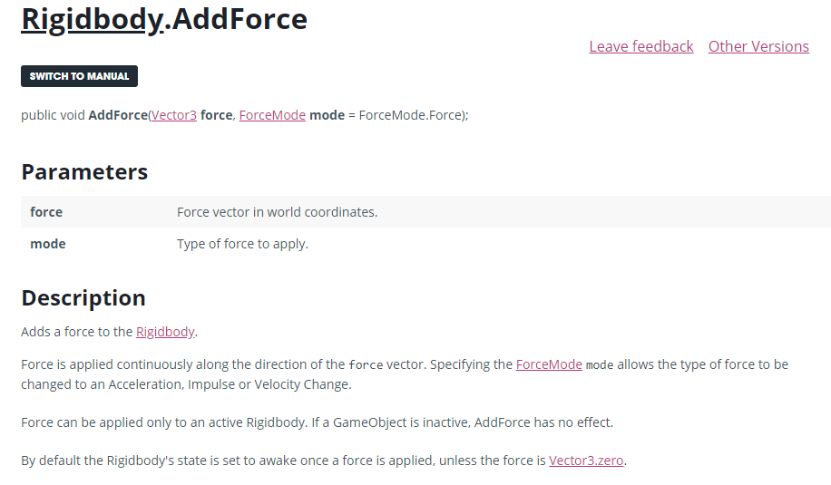

[*https://docs.unity3d.com/ScriptReference/Rigidbody.AddForce.html*](https://docs.unity3d.com/ScriptReference/Rigidbody.AddForce.html)

# Coding Session Two

Basic Movement: During my second coding session I decided to refine my player movement so that instead of keeping the velocity as it moved a changed direction it would stop and immediately change. After trying out different methods of doing so I found my solution, the solution I had found was in the form “Forcemode.velocitychange” and “rb.velcoty = vector3. Zero”.

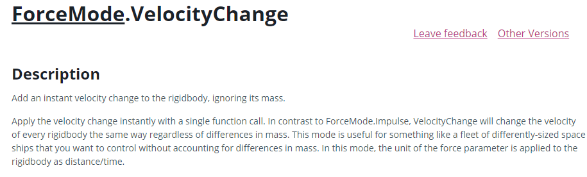

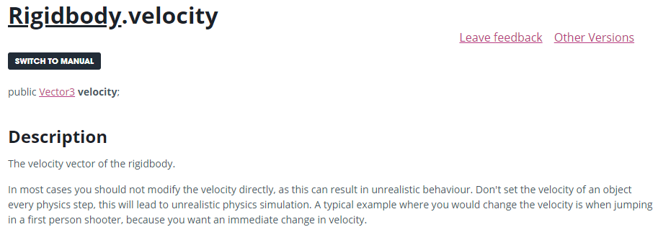

[*https://docs.unity3d.com/ScriptReference/ForceMode.VelocityChange.html*](https://docs.unity3d.com/ScriptReference/ForceMode.VelocityChange.html)

[*https://docs.unity3d.com/ScriptReference/Rigidbody-velocity.html*](https://docs.unity3d.com/ScriptReference/Rigidbody-velocity.html)

# Coding Session Three

Shooting: I found that there were multiple ways of doing shooting in unity and It took me a while to settle on one that would work for my player. I had decided to instantiate my projectile on my player Object and add a vector 3 offset.

I also learnt how to create a delay between each shot when the space bar is being held down with the help of a Unity answers user which also helped me understand the way “Time.deltaTime” worked.

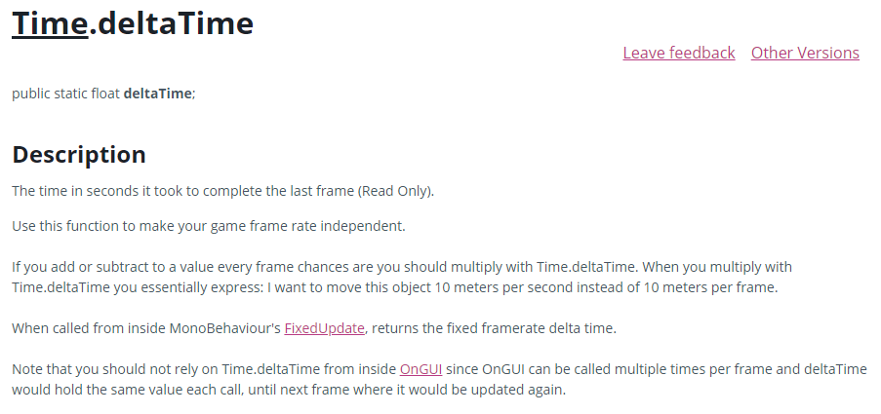

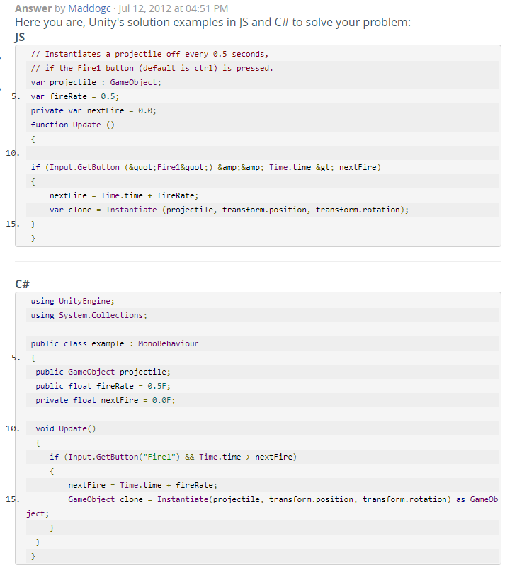

[*https://docs.unity3d.com/ScriptReference/Time-deltaTime.html*](https://docs.unity3d.com/ScriptReference/Time-deltaTime.html)

[*https://answers.unity.com/questions/283377/how-to-delay-a-shot.html*](https://answers.unity.com/questions/283377/how-to-delay-a-shot.html)

# Coding Session Four

Projectile Movement: Now that I was able to instantiate my object, I needed to learn how to make it move. Using what I had learnt from my player movement script I was able to figure out how to make the object simply fly forward in the direction that the player was facing.

I also had to figure out how to make the object delete itself since I didn’t want the projectile to exist forever, O I learnt how to destroy game objects and from that I learnt how to delete an object upon colliding with something.

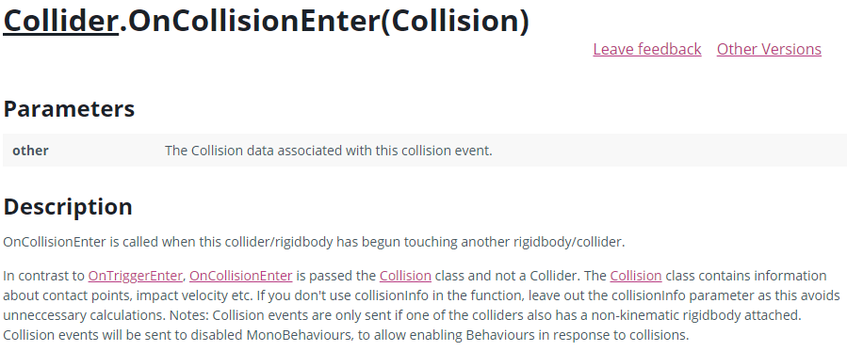

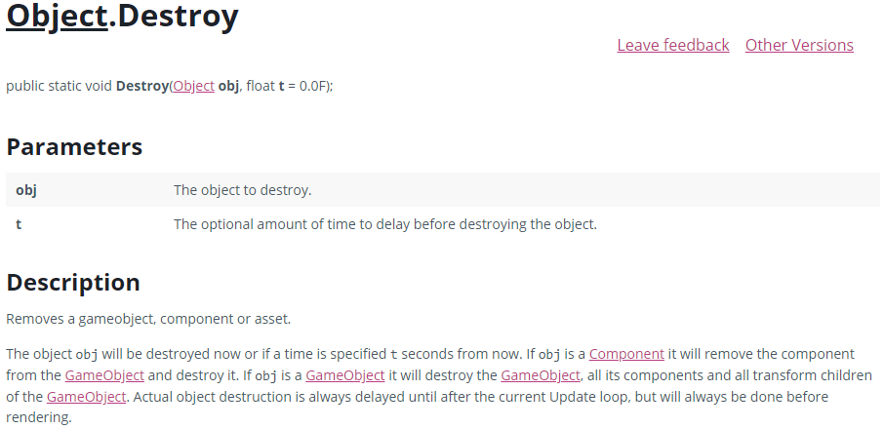

[*https://docs.unity3d.com/ScriptReference/Collider.OnCollisionEnter.html*](https://docs.unity3d.com/ScriptReference/Collider.OnCollisionEnter.html)

[*https://docs.unity3d.com/ScriptReference/Object.Destroy.html*](https://docs.unity3d.com/ScriptReference/Object.Destroy.html)

# Coding Session Five

Shielding: I wanted a way to make a shield form around the player object as if it was under attack and required protection. I thought of maybe toggling off the mesh render and collider as needed but decided against knowing there must have been another way. After a little bit of research I found that you can toggle objects on and off as a whole using SetActive.

I also had to figure out how to make it deplete and recharge as if it was using up energy when it was being used. As a solution a simple created a float with a max value and subtracted from that value as long as a key was being held and increase when it was not.

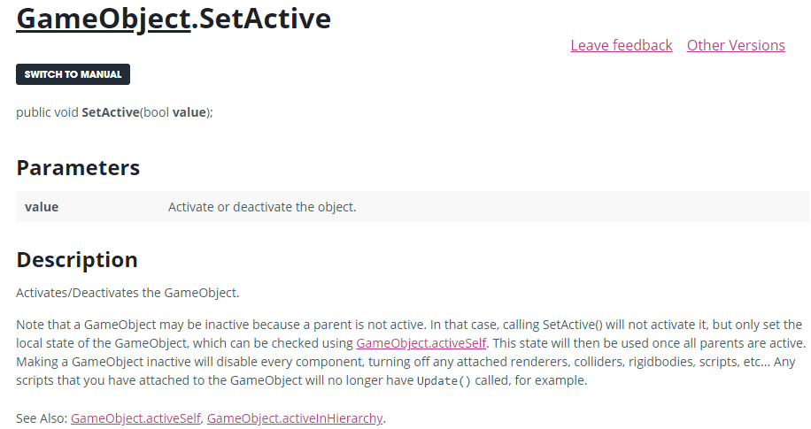

*<https://docs.unity3d.com/ScriptReference/GameObject.SetActive.html>*